**Department of Computer Engineering**

**University of Peradeniya CO226-Database Systems**

Lab Sheet Number : 05

Topic: Writing SQL Queries – Part I

Reg. No: E/18/397

**Task 1**

* Creating the database

create database E18397Lab05;

show databases;

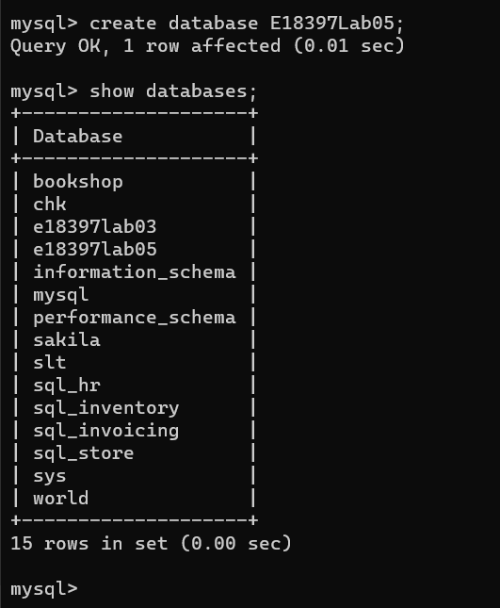

Figure 01: Database created

* Creating tables

create table Movie(

Mid int AUTO_INCREMENT,

Title VARCHAR(40),

Year int(4),

Director VARCHAR(40),

PRIMARY KEY (Mid)

);

alter table Movie AUTO_INCREMENT = 101;

create table Reviewer(

Rid int AUTO_INCREMENT,

Name varchar(40),

PRIMARY KEY(Rid)

);

alter table Reviewer AUTO_INCREMENT = 201;

create table Rating(

Rid int,

Mid int,

Stars int(1),

Rdate date,

FOREIGN KEY(Rid) REFERENCES Reviewer (Rid) ON DELETE CASCADE ON UPDATE CASCADE,

FOREIGN KEY(Mid) REFERENCES Movie (Mid) ON DELETE CASCADE ON UPDATE CASCADE

);

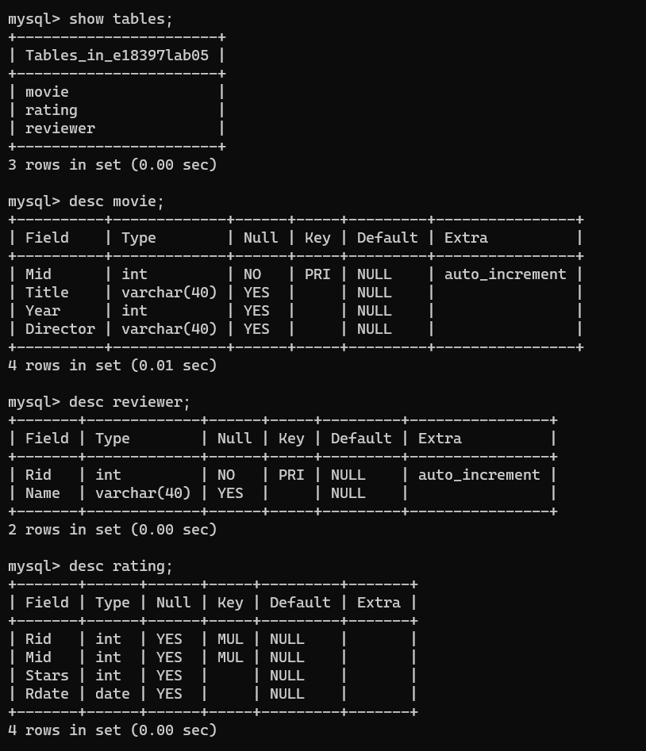

Figure 02: Tables after creating

* Adding data to the tables

insert into Movie(Title,Year,Director)

values

('Gone with the Wind',1939,'Victor Fleming'),

('Star Wars',1977,'George Lucas'),

('The Sound of Music',1965,'Robert Wise'),

('E.T.',1982,'Steven Spieibrg'),

('Titanic',1997,'James Cameron'),

('Snow White',1937,NULL),

('Avatar',2009,'James Cameron'),

('Raiders of the Lost Ark',1981,'Steven Spielberg');

insert into Reviewer(Name)

value

('Sarah Martinez'),

('Daniel Lewis'),

('Brittany Harris'),

('Mike Anderson'),

('Chris Jackson'),

('Elizabeth Thomas'),

('James Cameron'),

('Ashley White');

insert into Rating(Rid,Mid,Stars,RDate)

values

(201,101,2,'2011-01-22'),

(201,101,4,'2011-01-27'),

(202,106,4,NULL),

(203,103,2,'2011-01-20'),

(203,108,4,'2011-01-12'),

(203,108,2,'2011-01-30'),

(204,101,3,'2011-01-09'),

(205,103,3,'2011-01-27'),

(205,104,2,'2011-01-22'),

(205,108,4,NULL),

(206,107,3,'2011-01-15'),

(206,106,5,'2011-01-19'),

(207,107,5,'2011-01-20'),

(208,104,3,'2011-01-02');

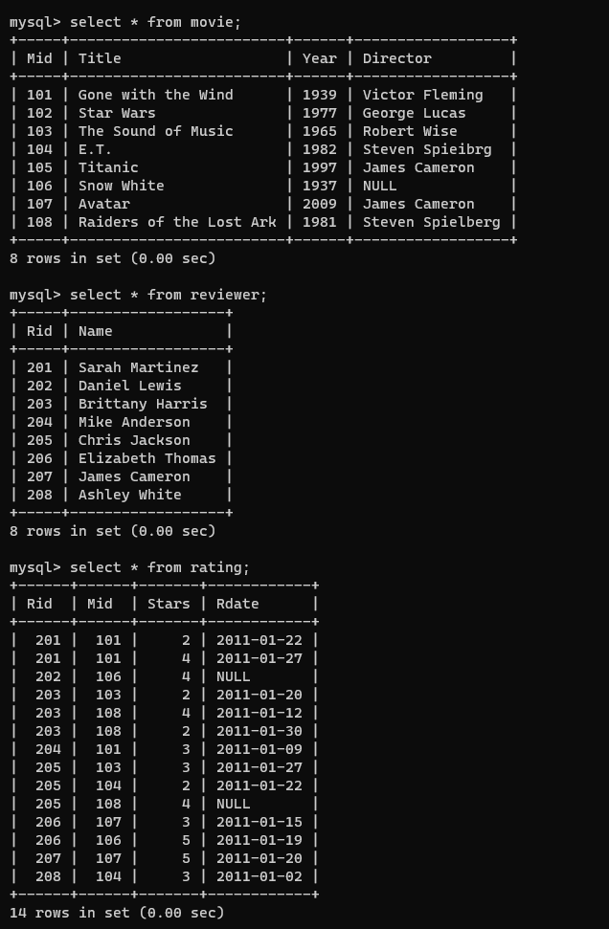

Figure 03: Tables after adding data

**Task 2**

1) select * from movie;

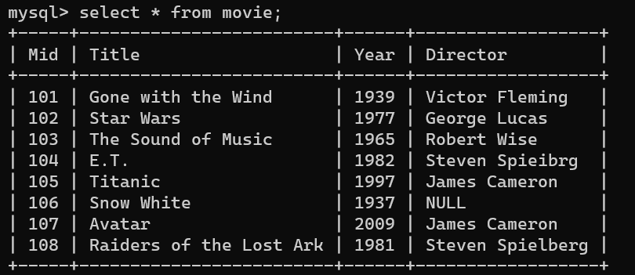

2) select * from movie where director = "James cameron";

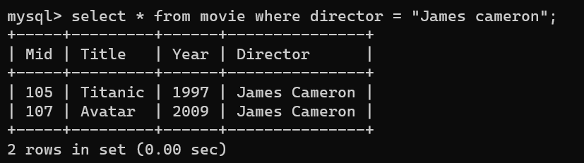

3) select * from Movie where Director='James Cameron'

AND Year>=2000

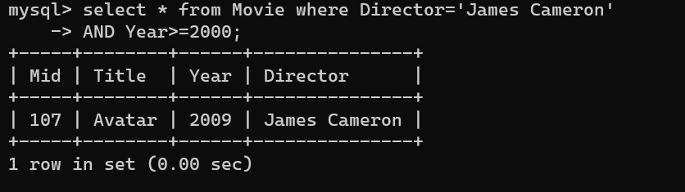

4) select stars from rating;

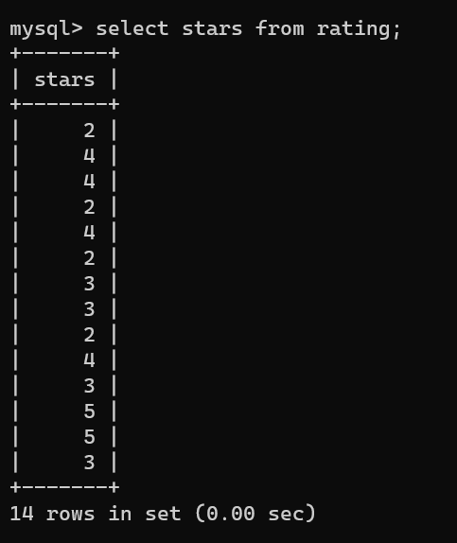

5) select distinct Stars from Rating;

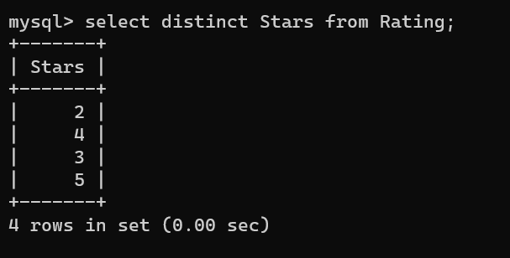

6) select Mid, Director from Movie;

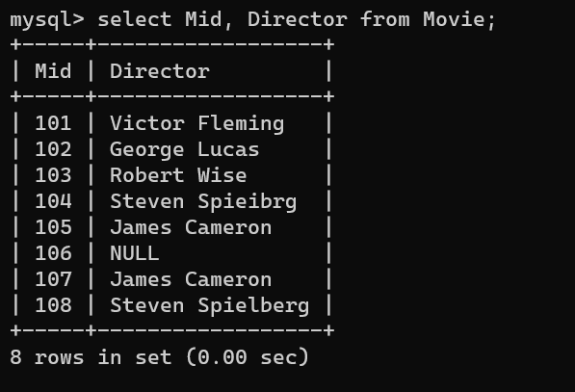

7) select Mid, title, Year from Movie where director = 'Steven Spielberg';

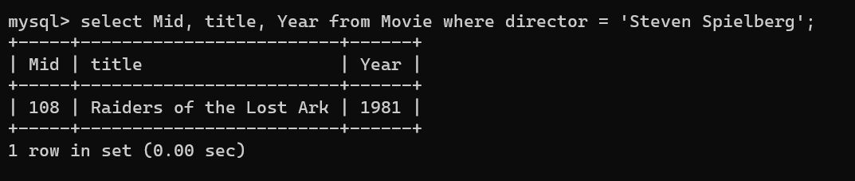

8) select * from Movie,Rating;

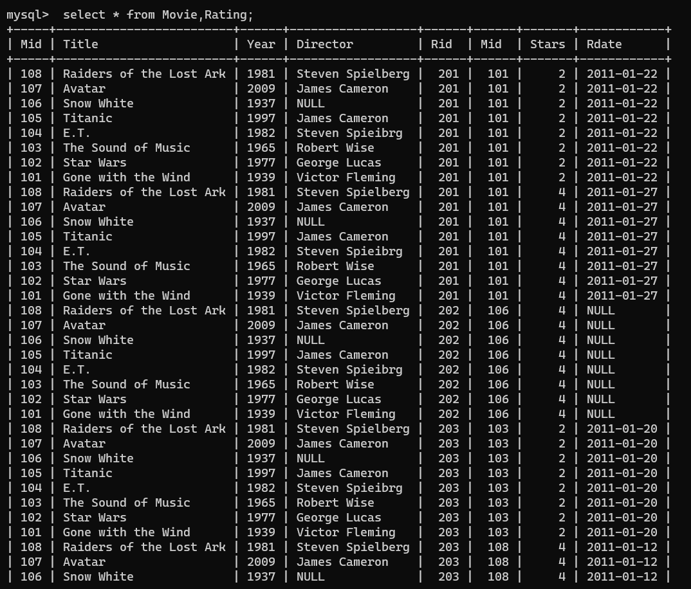

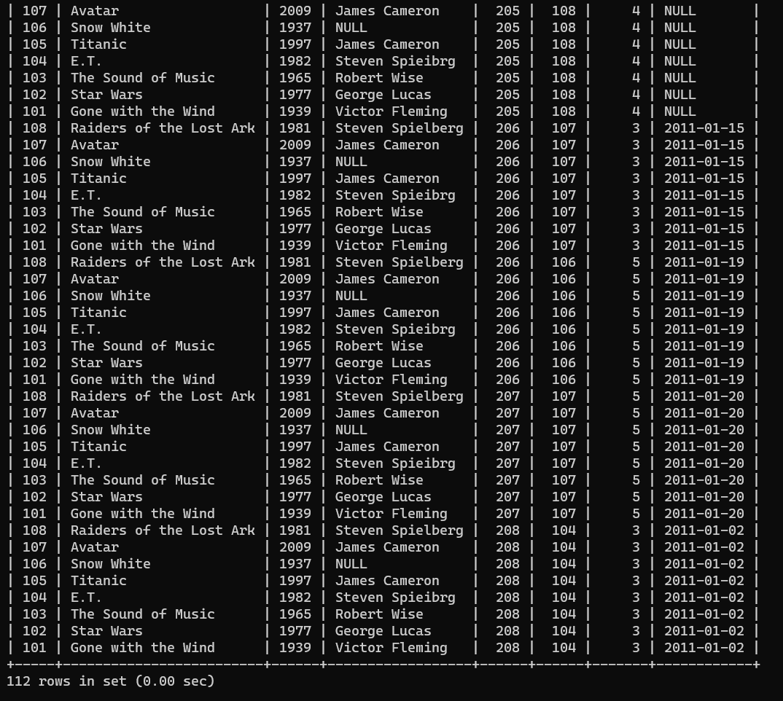

9) select a.Mid, a.Title,b.MId,b.RId,b.Stars from Movie a,Rating b;

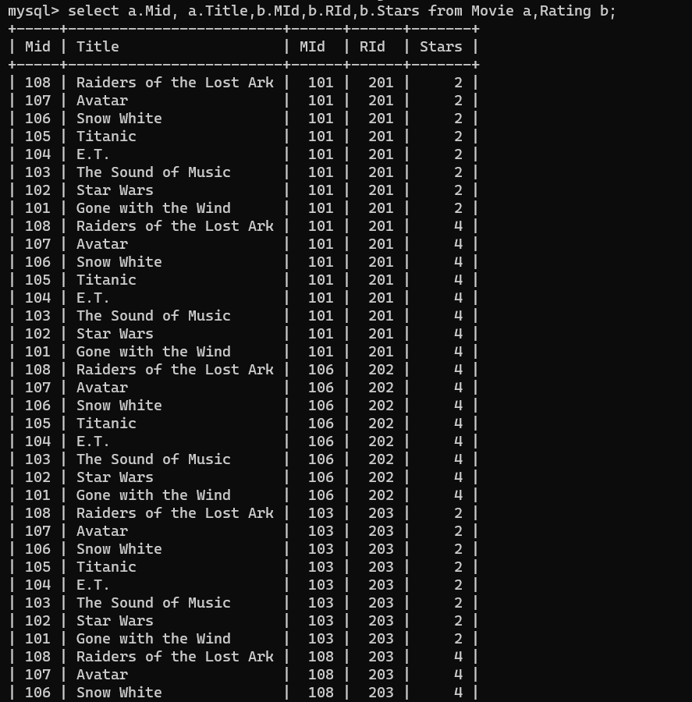

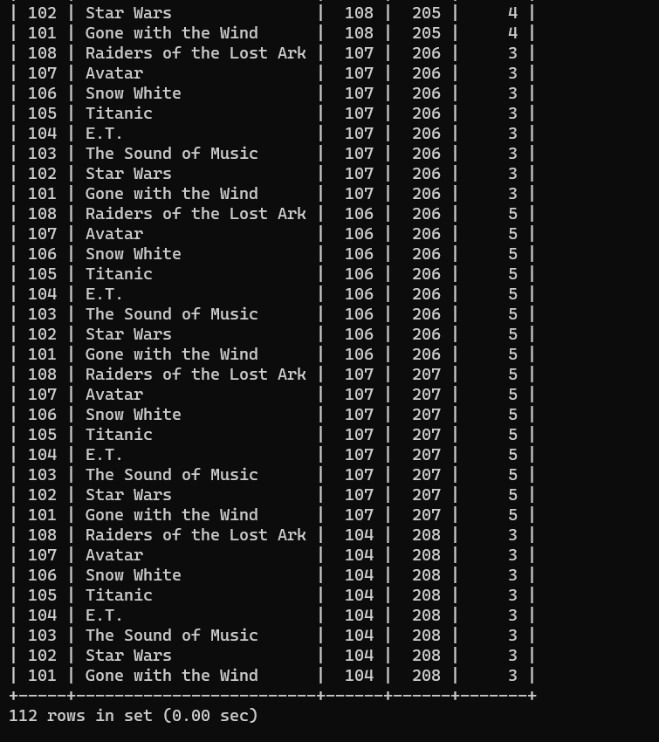

10) select a.Mid, a.Title,b.RId,b.Stars from Movie a,Rating b where a.Mid = b.Mid;

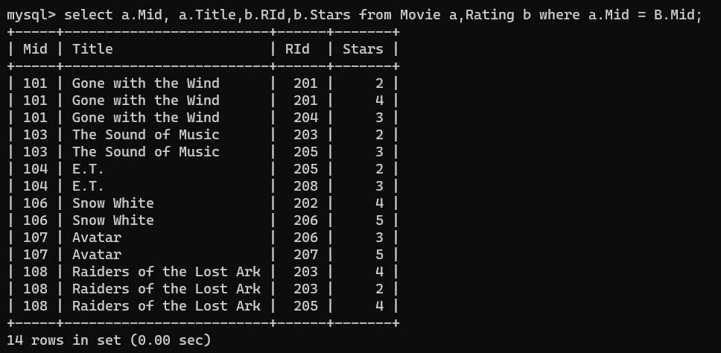

11) select a.Mid, a.Title,b.RId,b.Stars from Movie a,Rating b where a.Mid = b.Mid and b.stars<=3;

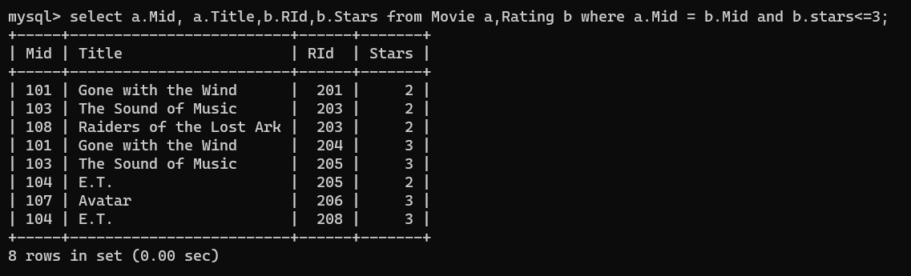

12) select a.Mid, a.Title,b.RId,b.Stars from Movie a,Rating b where a.Mid = b.Mid and b.stars>=2 and b.stars<=4;

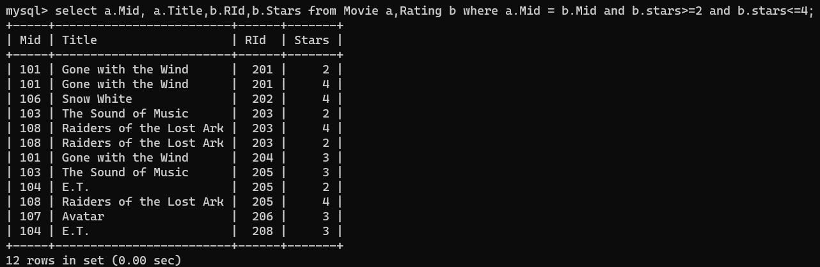

13) select Rid, Mid from Rating;

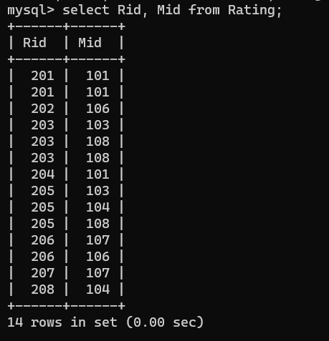

14) select distinct Rid, Mid from Rating;

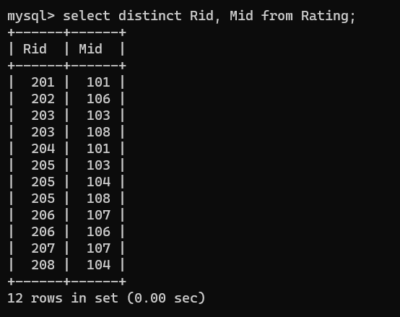

15) select a.Mid, a.Title,b.Rid, c.name, b.Stars from Movie a,Rating b, Reviewer c where a.Mid = b.Mid and b.Rid = c.Rid;

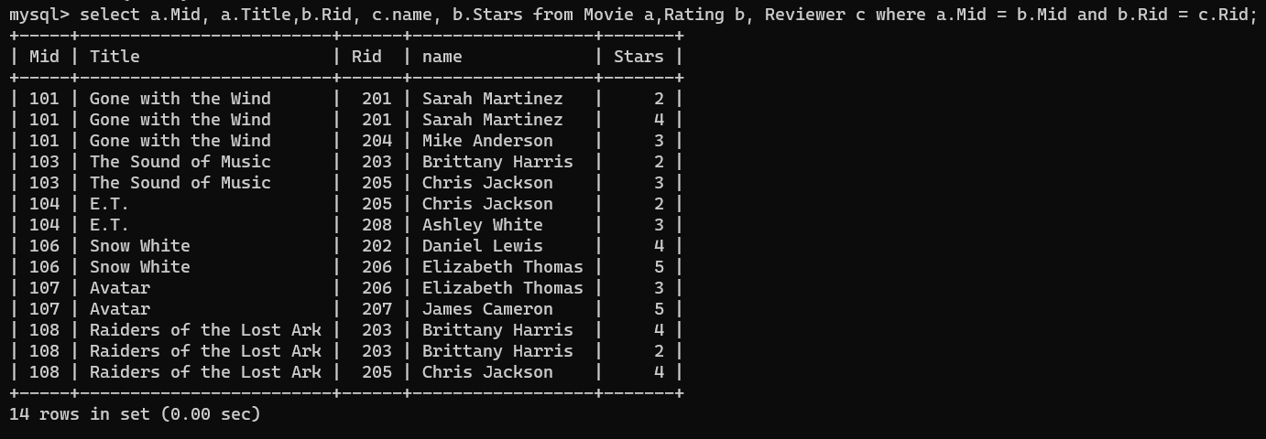

16) select a.Mid, a.Title,b.Rid, c.name, b.Stars from Movie a,Rating b, Reviewer c where a.Mid = b.Mid and b.Rid = c.Rid and b.stars =5;

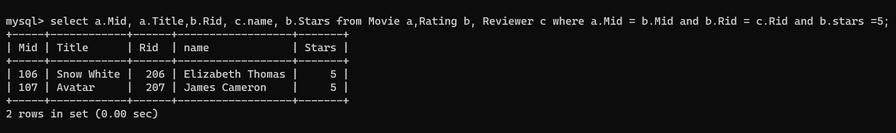

17) select a.Title, c.name, b.Stars from Movie a,Rating b, Reviewer c where a.Mid = b.Mid and b.Rid = c.Rid and b.Rdate is NULL ;

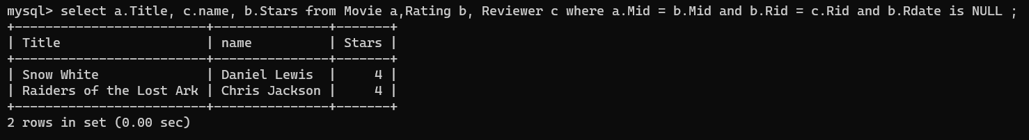

18) (select Director from Movie where Director is NOT NULL) UNION

(select Name from Reviewer where Name is NOT NULL);

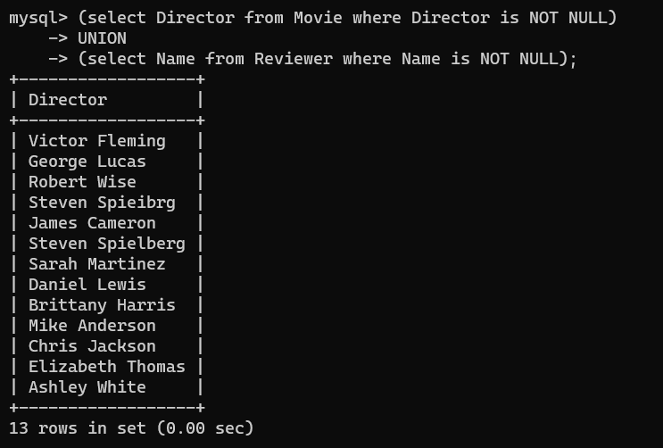

19) select * from Reviewer where Name LIKE '%Martinez%';

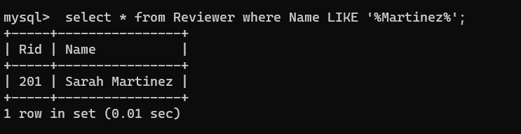

20) select * from rating where RDate LIKE '____-__-0_';

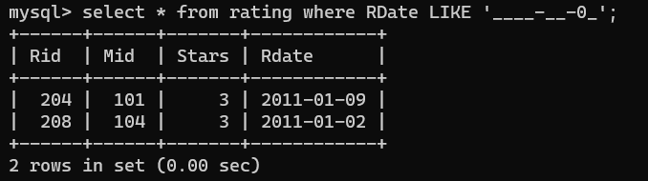

21) select * from rating where RDate < '2011-01-10';

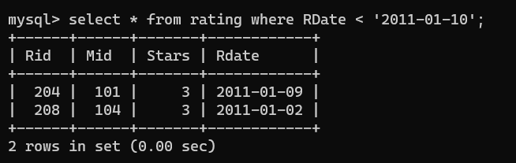

22) update Rating set Stars = Stars+1 where Rid=203;

select Rid,Mid,Stars from Rating where Rid=203;

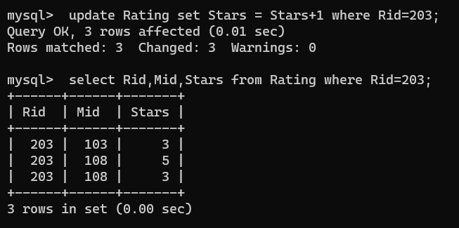

23) select a.Title, b.Name, c.Stars from Movie a, Reviewer b, Rating c where a.Mid = c.Mid and B.Rid = c.Rid ORDER BY a.Title;

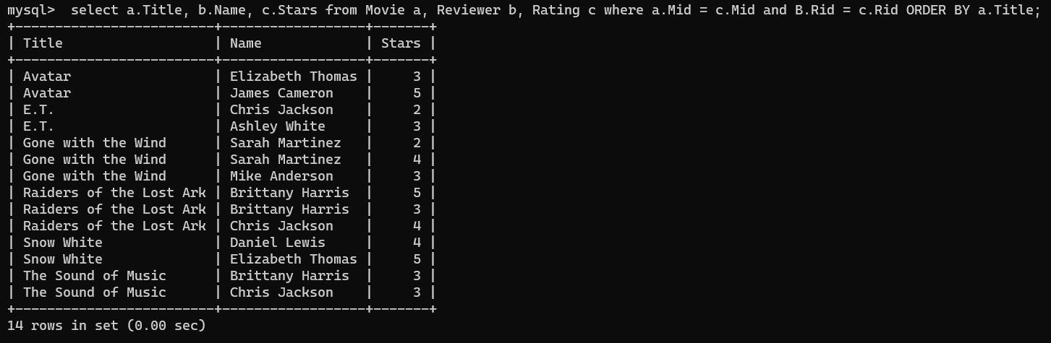

24) select a.Title, c.Stars, c.Rdate from Movie a, Rating c where a.Mid = c.Mid ORDER BY a.Title;

select a.Title, c.Stars, c.Rdate from Movie a, Rating c where a.Mid = c.Mid ORDER BY c.Stars DESC;

select a.Title, c.Stars, c.Rdate from Movie a, Rating c where a.Mid = c.Mid ORDER BY c.Rdate DESC;

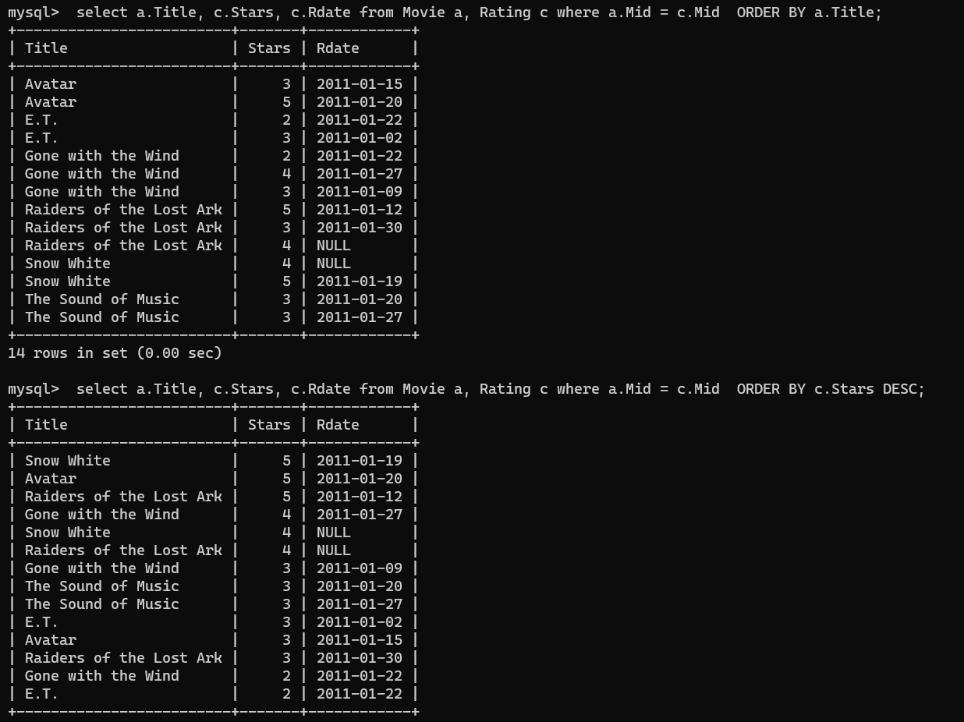

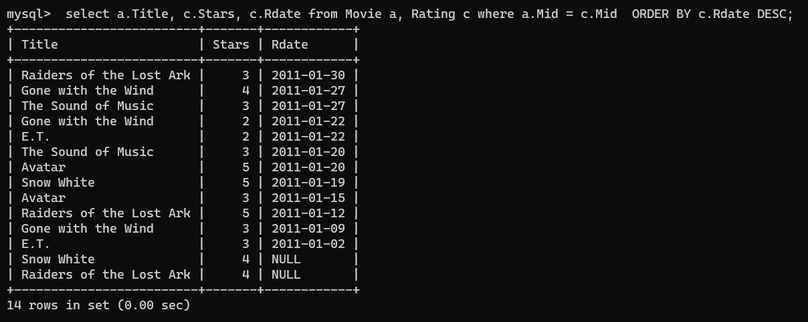

25) select * from Movie where Director in (select Name from Reviewer);

